Name: - Atharva Athanikar

Roll No.:- TCOA44

Div.: - A

Title: - Installation and configure Google app engine.

Step 1:- Search Google Cloud Platform in any search engine & Click on Console.

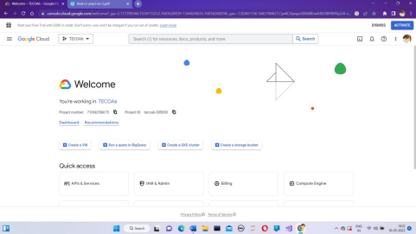

Step 2:- Click on select new project.

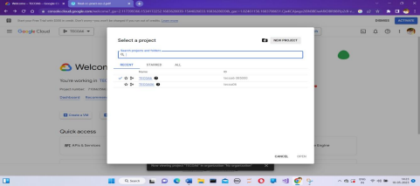

Step 3:- Give Project name and click on create.

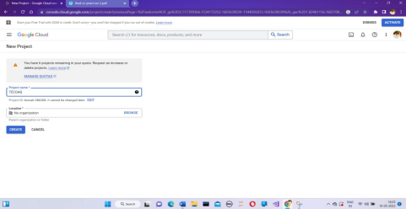

Step 4:- Click on select project

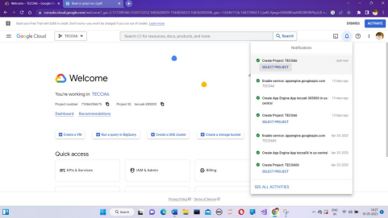

Step5:- In a search bar type search App Engine

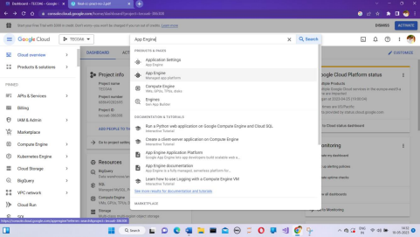

Step 6:- Click on App Engine and following screen will appear& Click on Create Application.

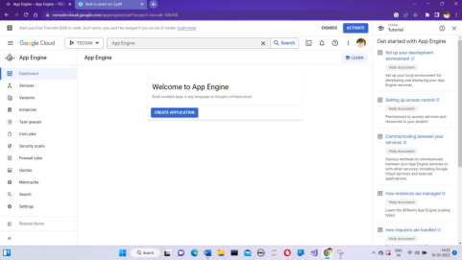

Step 7:- Click on next

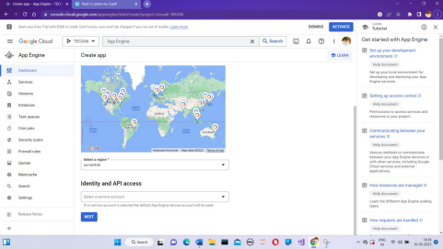

Step 8:- Scroll down and click on l’ll do this later.

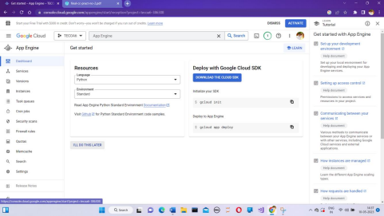

Step 9:- In search bar type App Engine Admin API.

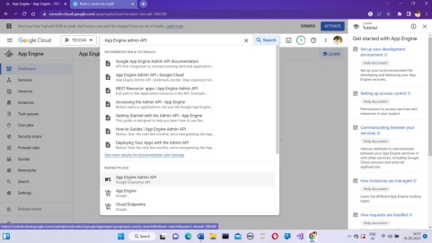

Step 10:- Click Enables

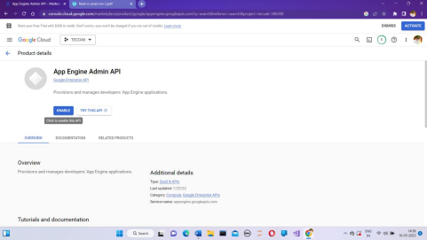

Step 11:- Click Activate Cloud Shell:-

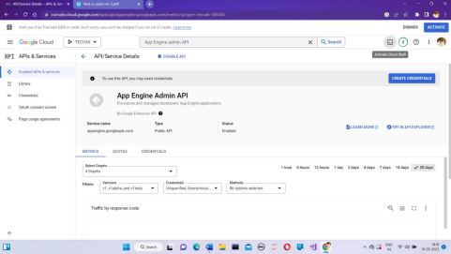

Step 12:- Following screen will appear.

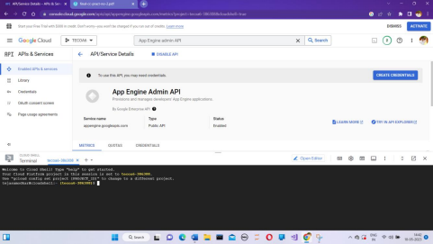

Step 13:- Login into your GitHub account and click on new repository.

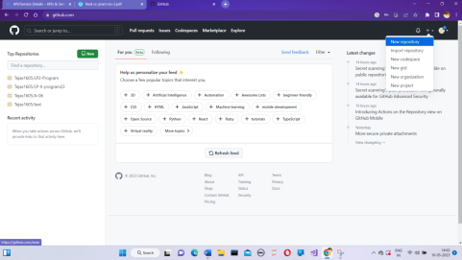

Step 14:- Give name to your repository and click create.

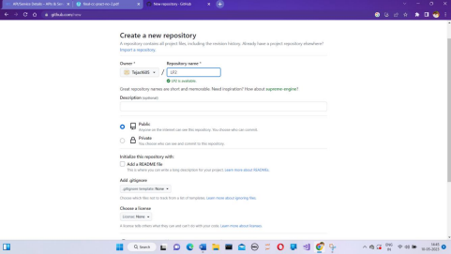Step 15:- Click on creating new file.

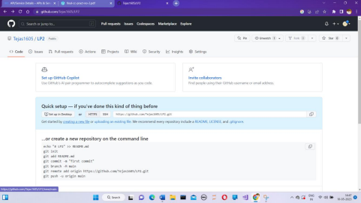

Step 16:- Give name to the python file & type your code.

Step 17:- Click on code and copy URL.

Step 18:- Go to cloud and type – git clone and paste url.

Step 19:- Type ls.

Step 20:- Enter cd-repository name.

Step 21:- Type ls and to run python code type python-program name.